Launch and connect to an instance, and then switch to the root user.
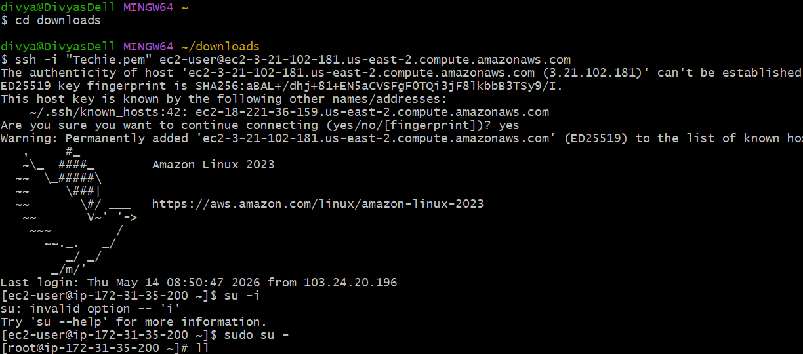
Conditional Statements in Bash Script Using if-else
Example 1
Outcome:- Successfully created and executed a Bash shell script using conditional statements (if-else) to validate numeric values.
Objective:-
The objective of this task is to understand how conditional statements work in Bash scripting. This task helps in learning decision-making logic where the script performs different actions based on conditions.
Prerequisites:- Before performing this task, the following were required:
- Linux machine access
- Bash shell environment
- Basic understanding of shell scripting
- Text editor like vi or nano
Implementation Steps
Step 1: Create Script File vi ifelse-scripts.bash ---This command creates and opens a new Bash script.
Step 2: Write the if-else Script
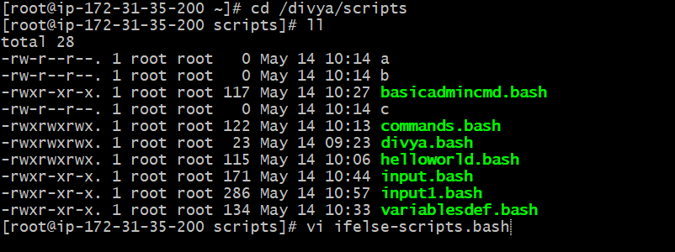
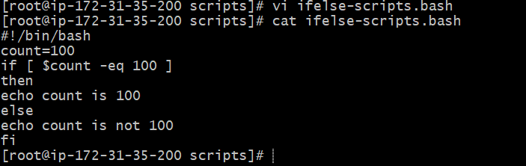
Script Explanation
Statement | Purpose
count=100 | Variable declaration
if | Starts condition
-eq | Numeric comparison
then | Executes TRUE block
else | Executes FALSE block
fi | Ends if block
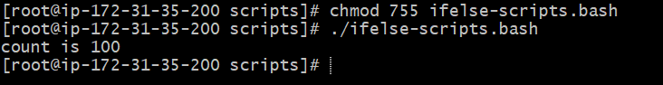
Step 3: Assign Execute Permission using chmod 755 ifelse-scripts.bash
Step 4: Execute Script Command Used ./ifelse-scripts.bash
Expected Output count is 100
Validation Scenario: Modified if-else Condition
Change Performed
In the original script, the variable value was: count=100
It was modified to: count=30
Output Obtained count is not 100
Explanation --- The condition inside the script checks whether the value of count is equal to 100.
if [ $count -eq 100 ]
Since the value was changed from 100 to 30, the condition became FALSE.
Therefore:
- The then block was skipped
- The else block executed
As a result, the output displayed:
count is not 100
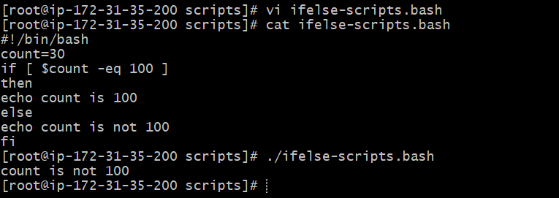
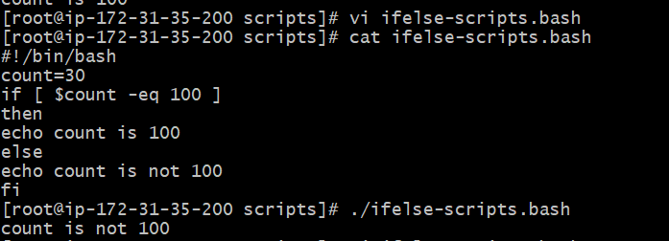
Example 2 ---Create a Bash Script to Check Whether a File Exists or Not
Outcome:- Successfully created and executed a Bash shell script to verify whether a file exists in the Linux system.
Objective: The objective of this task is to understand how to check file availability using conditional statements and file test operators in Bash scripting.
Step-by-Step Implementation
Step 1: Create Script File using vi ifelse1.scripts.bash ---This command creates and opens a shell script
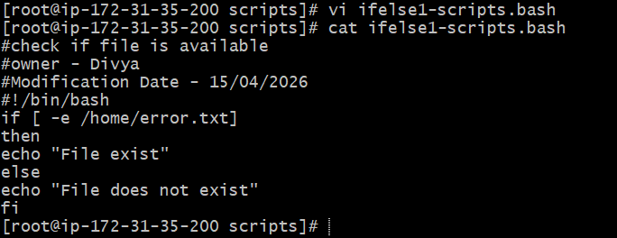
Step 2: Write the Script
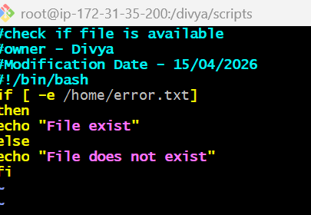
Script Explanation
Statement | Purpose
-e | Checks whether file exists
if | Starts condition
then | Executes TRUE block
else | Executes FALSE block
fi | Ends condition
What is -e? -e is a Bash file test operator. It checks whether: File exists or Directory exists
Step 3: Assign Execute Permission ---- chmod 755 check-file.sh
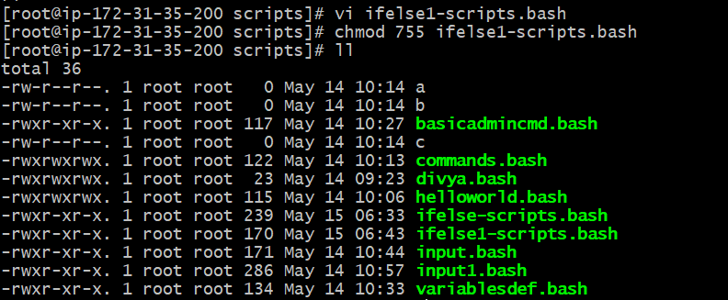
Step 4: Verify Permission using --- ll
Expected Output -rwxr-xr-x
Step 5: Execute the Script ./ifelse1-scripts.bash OR bash ifelse1-scripts.bash
Expected Output (If File Exists) --- File exist
Expected Output (If File Does Not Exist) --- File does not exist
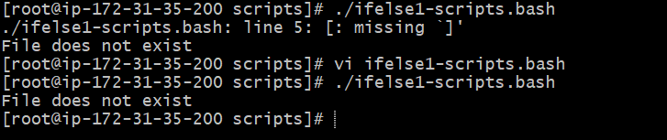
Difference Between -e, -f, and -d
Operator | Purpose
-e | Checks existence
-f | Checks regular file
-d | Checks directory
Changing the location and testing
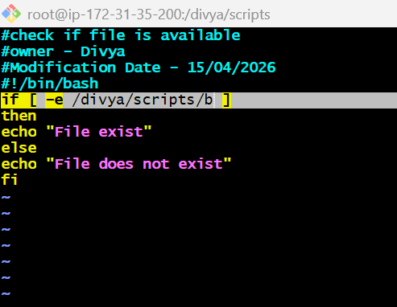

Bash Script Using Case Statement
Outcome:- Successfully created and executed a Bash script using a case statement to perform different operations based on user-selected options.
Objective:- To understand how case statements work in Bash scripting and how they are used to handle multiple choices or conditions in a script.
Implementation Steps
Step 1: Create a new script file using vi case-script.bash . This command creates and opens the script file for editing.
Step 2: Write the Script
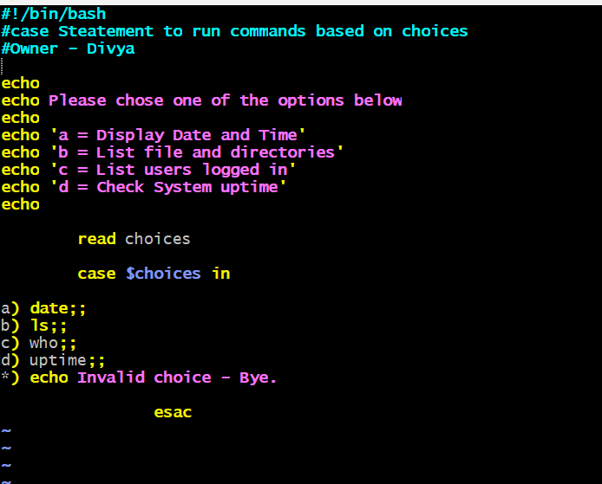
Description:-
- echo → Displays menu options
- read choices → Accepts user input
- case → Starts case statement
- a) → Executes date command
- b) → Executes ls command
- c) → Executes who command
- d) → Executes uptime command
- *) → Default option for invalid input
- ;; → Ends each condition block
- esac → Ends case statement
Step 3: Provide Execute Permission --- chmod 755 case-script.bash
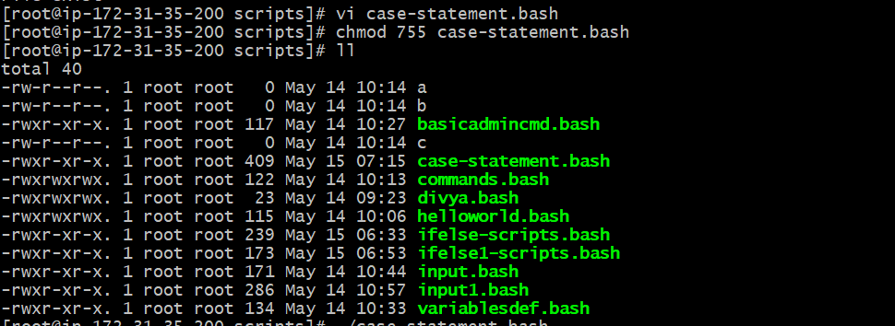
Step 4: Execute the Script using ./case-script.sh
Step 5: Test Different Options
Option A: Display Date and Time
Input: a
Expected Output: Displays current system date and time.
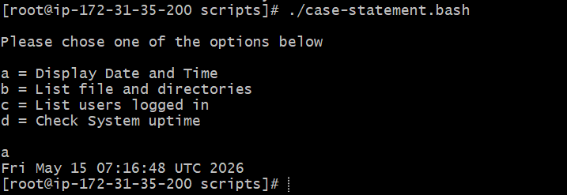
Option B: List Files and Directories
Input: b
Expected Output: Displays files and directories using ls.
Option C: List Logged-In Users
Input: c
Expected Output: Displays logged-in users using who.
Option D: Check System Uptime
Input: d
Expected Output: Displays system uptime.
Invalid Option Test
Input: x
Expected Output: Invalid choice - Bye.

Bash Script Using For Loop
Outcome:- Successfully created and executed a Bash script using a for loop to repeat commands multiple times.
Objective:- To understand how for loops work in Bash scripting and how loops are used to execute commands repeatedly based on specified values.
Implementation Steps
Step 1: Create Script File vi loop-script1.bash
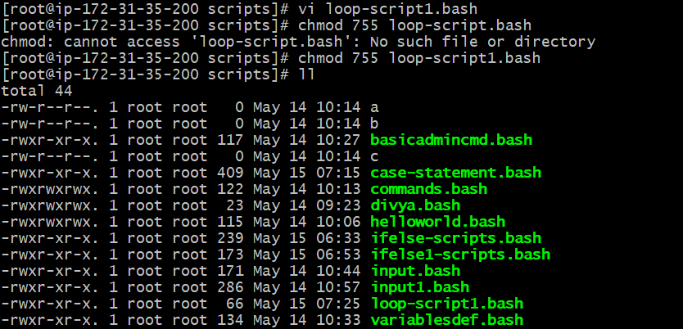
Step 2: Write the Script
Description:-
- for → Starts loop statement
- i → Variable used in loop
- in 1 2 3 4 5 → Values assigned one by one
- do → Starts loop execution block
- echo → Prints output
- $i → Displays current variable value
- done → Ends loop
The loop executes 5 times because 5 values are provided.
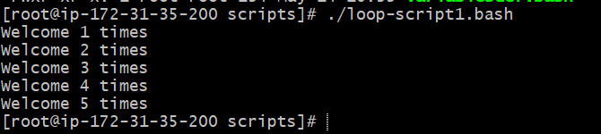
Step 3: Provide Execute Permission --- chmod 755 for-loop.sh
Step 4: Execute the Script -- ./for-loop.sh
Expected Output:
Welcome 1 times
Welcome 2 times
Welcome 3 times
Welcome 4 times
Welcome 5 times
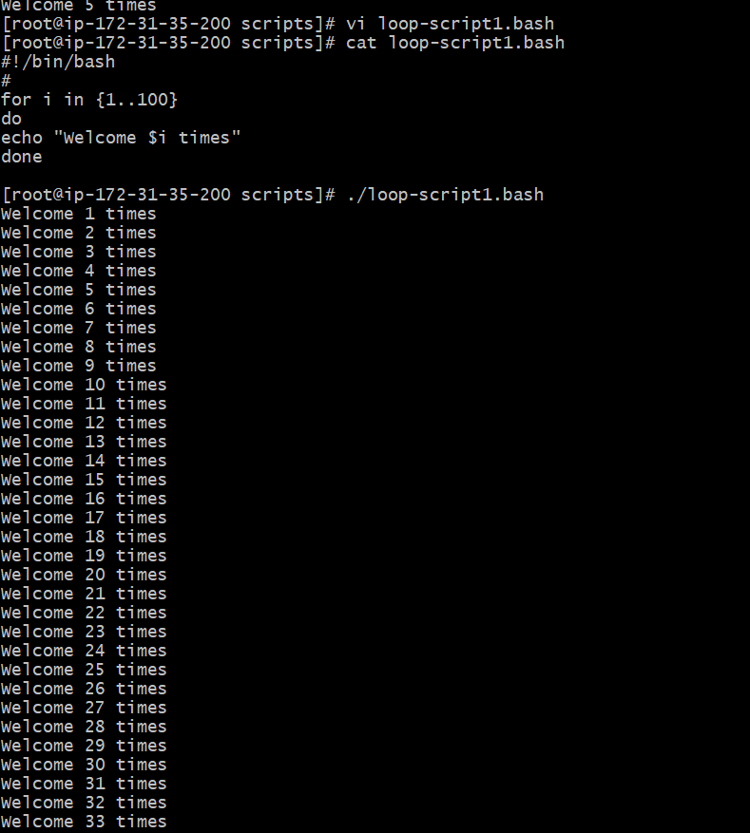

Bash Script Using For Loop with String Values
Outcome:- Successfully created and executed a Bash script using a for loop with multiple string values.
Objective:- To understand how for loops work with string values in Bash scripting and how commands are executed repeatedly for each value.
Implementation Steps
Step 1: Create a new script file using: vi for-loop.bash. This command creates and opens the script file for editing.
Step 2: Write the Script
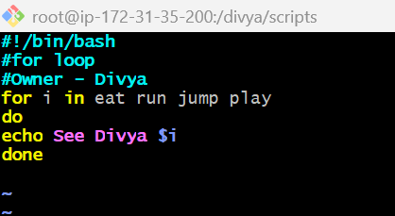
Description:-
- for → Starts loop statement
- i → Variable used in loop
- eat run jump play → Values assigned one by one
- do → Starts loop block
- echo → Prints output
- $i → Displays current variable value
- done → Ends loop
Step 3: Provide Execute Permission chmod 755 for-loop.bash
Step 4: Execute the Script using ./for-loop.bash
Expected Output:
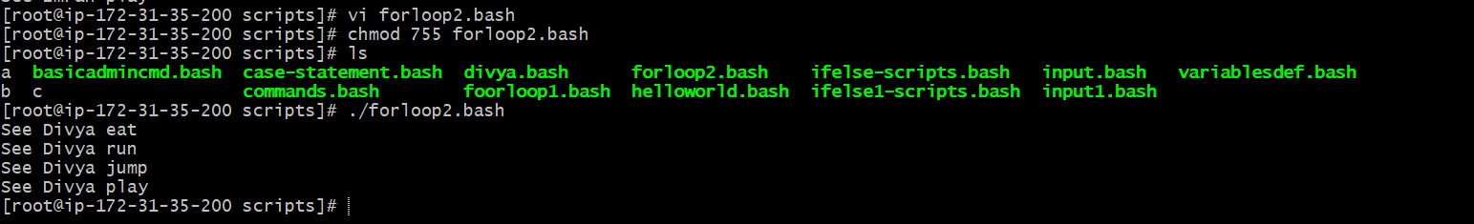
Do-While
Bash Script Using While Loop
Outcome:- Successfully created and executed a Bash script using a while loop to perform a countdown process repeatedly until the condition becomes false.
Objective:- To understand how while loops work in Bash scripting and how they are used to execute commands continuously based on conditions.
Implementation Steps
Step 1: Create a new script file using --- vi while-loop.bash
This command creates and opens the script file for editing.
Step 2: Write the Script
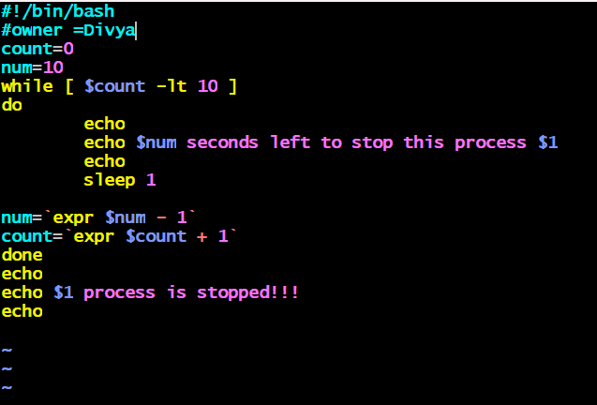
Description:-
- count=0 → Initializes loop counter
- num=10 → Countdown value
- while → Starts loop based on condition
- -lt → Less than comparison operator
- echo → Prints output
- sleep 1 → Pauses execution for 1 second
- expr → Performs arithmetic operations
- $1 → Accepts command-line argument
- done → Ends while loop
The loop runs until the value of count becomes 10.
Step 3: Provide Execute Permission
chmod 755 while-loop.bash
This command provides execute permission to the script file.
Step 4: Execute the Script using ./while-loop.bash
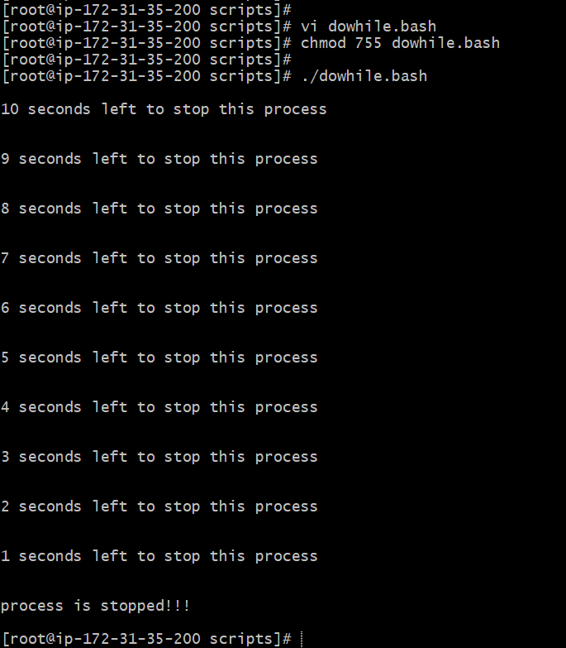
Exit status
Bash Script Using Exit Status
Outcome:- Successfully learned and tested Linux exit status codes using Bash scripts to verify whether commands execute successfully or fail.
Objective:- To understand what exit status is in Linux, how to check command execution status, and how exit codes are used in Bash scripting for validations and conditions.
Exit Status Overview Every command executed in Linux returns an exit status.
Exit Status Values
Exit Status | Meaning
0 | Command successful
1 | Minor problem
2 | Serious problem
3-255 | Other errors
Why Do We Need Exit Status?
Exit status is used in scripting to verify whether a command executed successfully or failed.
Example:
- If command succeeds → Execute next action
- If command fails → Display error or stop execution
How to Check Exit Status?
Command: echo $?
$? displays the exit status of the previously executed command.
Example 1: Successful Exit Status
Step 1: Create Script File
vi exitstatus1.bash
Step 2: Write the Script
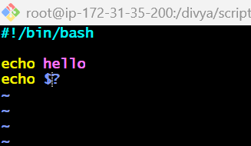
Description:-
- echo hello executes successfully
- echo $? displays previous command exit status
Step 3: Provide Execute Permission chmod 755 exit-status-success.bash

Step 4: Execute the Script -- ./exit-status-success.bash
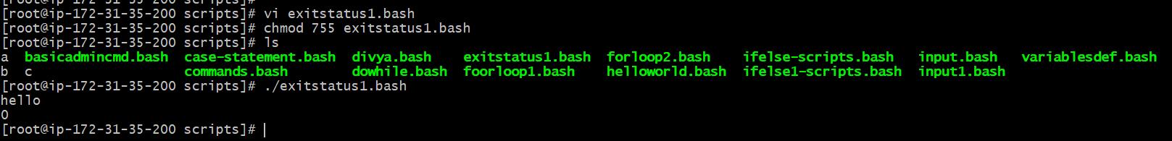
Explanation The command executed successfully, so the exit status returned is: 0
Example 2: Unsuccessful Exit Status
Step 1: Create Script File
vi exitstatus2.bash
Step 2: Write the Script
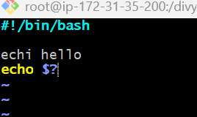
Description:-
- echi is an invalid command
- Linux cannot execute it
- Exit status becomes non-zero
Step 3: Provide Execute Permission --- chmod 755 exit-status-fail.bash
Step 4: Execute the Script ---./exit-status-fail.bash
Expected Output
echi: command not found
127
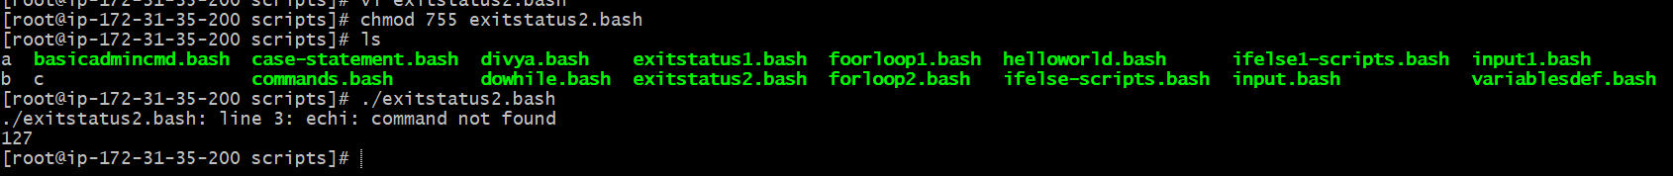
Explanation Since echi is not a valid command, Linux returns an error exit status.
Example 3: Check File Existence Using Exit Status
Step 1: Create Script File--vi exirstatus3.bash
Step 2: Write the Script
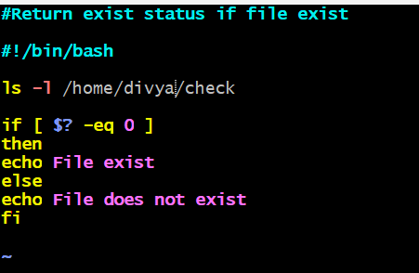
Description:-
- ls -l checks whether file/directory exists
- $? stores previous command exit status
- if condition checks exit status
- 0 means file exists
- Non-zero means file does not exist
Step 3: Provide Execute Permission --- chmod 755 exitstatus3.bash
Step 4: Execute the Script ./exitstatus3.bash
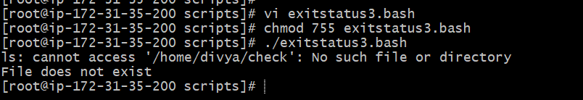
Common Real-Time Scripts Used in Cron Jobs
1. Objective --- Automate disk space monitoring in Linux using:
- Bash scripting
- Crontab scheduling
- Log file generation
Requirement ---Create a script that:
- checks disk usage
- stores report in a log file
- executes automatically every minute using cron

Script Location
/divya/scripts/check-disk.sh
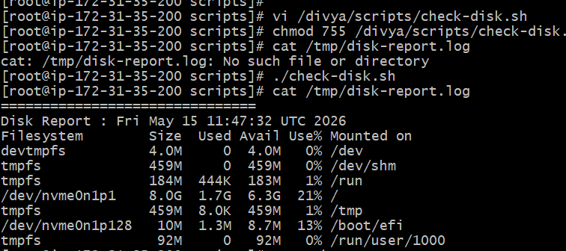
Bash Script
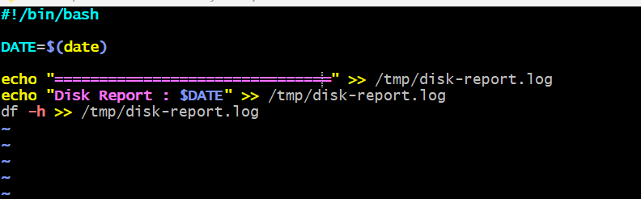
Script Explanation
Command | Description
#!/bin/bash | Defines bash interpreter
echo | Prints text
$(date) | Displays current date and time
df -h | Shows disk usage in human-readable format
>> | Appends output to log file
Give Execute Permission --- chmod 755 /divya/scripts/check-disk.sh
Manual Script Execution --- ./check-disk.sh
Output Log File --- /tmp/disk-report.log
Configure Cron Job
Open crontab editor:
crontab -e
Add cron entry:
*/1 * * * * /divya/scripts/check-disk.sh
